Name of the Student: G. Manasa | Academic Year: 2025-26
Student Registration Number: 241U1R3007 | Year & Term: II & I
Study Level: UG | Class & Section: CSE-DS-2A
Name of the Course: PYTHON PROGRAMMING | Name of the Instructor: Mr. Pranay Vemula, Assistant Professor, CSE.
Name of the Assessment: CA | Date of Submission: 24-09-2025

Open Lab Test
7. Create a function that accepts a heterogeneous list and separates all numeric values into even and odd lists, preserving original positions.
INPUT:
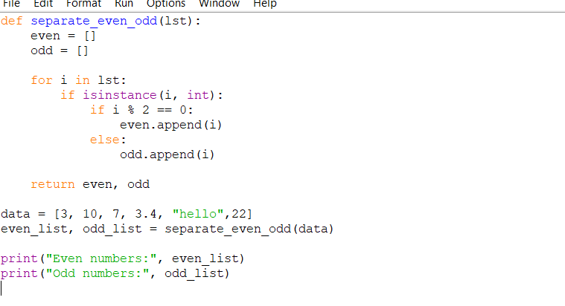

OUTPUT:
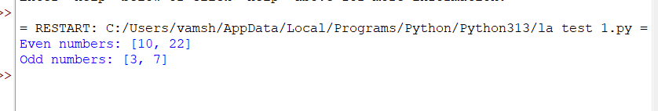

17. Using NumPy, generate a 6x6 matrix with random integers. Replace elements on the diagonal with 0 and compute matrix transpose and determinant.
INPUT:
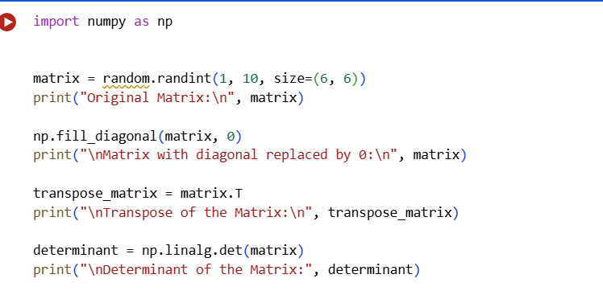

OUTPUT:
